

**FPT ACADEMY INTERNATIONAL**

**FPT – APTECH COMPUTER EDUCATION**

**Installation Guide**

**Otakool – Anime store**

**Project - Group III – T1.2109.E0**

**I. System Requirement**

|  |  |  |
| --- | --- | --- |
| **No** | **Software** | **Description** |
| 1 | Operating system | Windows, MacOS |
| 2 | Hardware | Core I3, Ram 4gb, Storage 2gb |
| 3 | Software | Xampp, mysql, php |
| 4 | Web browser | Chrome, Firefox, Edge ,... |

**II. Copy website folder:**

* Unzip Otakool.zip and open it up in IDE of choice (VSCode recommended)
* Open file environment.env to setup connect database mysql.
  + DB_CONNECTION=mysql
  + DB_HOST=127.0.0.1
  + DB_PORT=3306
  + DB_DATABASE=otakool
  + DB_USERNAME=root
  + DB_PASSWORD=
* Change DB_USERNAME and DB_PASSWORD if you have anything different in file xampp\phpMyAdmin\config.inc.php (default is ‘root’ and password is empty)



* Go to phpMyAdmin create Database name like **DB_DATABASE** (Example: otakool)

**III. Test:**

* Open XAMPP and make sure Apache and MySQL are started and running
* Open Otakool-demo in terminal (in VSCode recommended)
* Run command > php artisan db:seed
* This will generate a main admin base on file (database\factories\AdminFactory.php):
* Run command > php artisan serve



When setup success access link <http://127.0.0.1:8000> (or if you are using VSCode: Ctrl + left Click the link shown)

* The website homepage will open like this.





* To access the admin page, add “/admin/login” after the link above

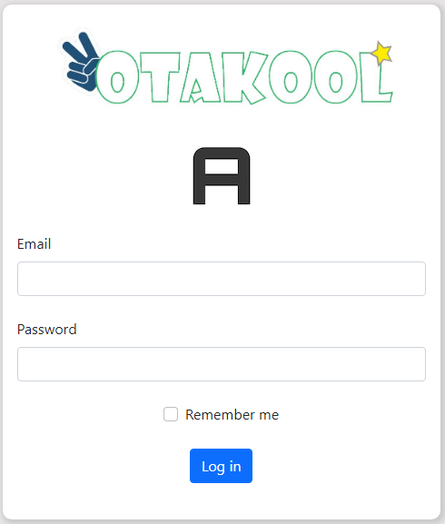

* + Email: [main.admin@gmail.com](mailto:main.admin@gmail.com)
  + Password: password
* After login as a main admin:

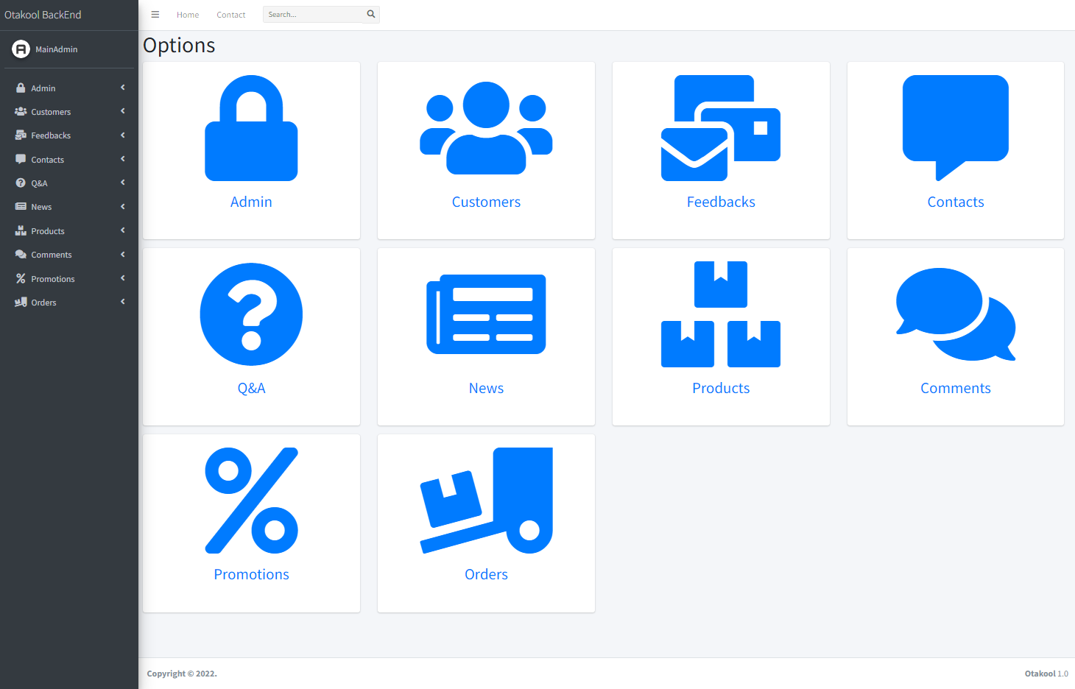

* Note:
* To validate inputted email, intl extension is required
* In xampp\php\php.ini, change ';extension=intl' into 'extension=intl' (remove ‘;’)

**IV. To access sample Database:**

* Put otakool.sql in desired location
* Open XAMPP and make sure Apache and MySQL are already running
* Go to Shell

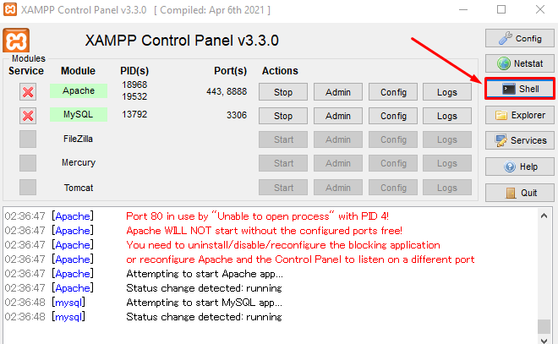

* Go to Shell
* To import data:

# mysql -u [DB_USERNAME] -p otakool < [desired location]\otakool.sql

Enter password: [DB_PASSWORD]

* To export data:

# mysqldump -u [DB_USERNAME] -p otakool > [desired location]\otakool.sql

Enter password: [DB_PASSWORD]

* Example:

